<div class="slider-section">

        <div id="carouselExampleIndicators" class="carousel slide" data-ride="carousel">

            <ol class="carousel-indicators">

                <?php $id = 0 ?>

                @foreach($sliders as $slider)

                    <li data-target="#carouselExampleIndicators" data-slide-to="{{$id++}}"></li>

                @endforeach

            </ol>

            <div class="carousel-inner">

                @foreach($sliders as $slider)

                <div class="carousel-item @if($slider->active_status == 'active') active @endif">

                    <img class="d-block w-100" src="{{asset('storage/'.$slider->slider_image)}}" alt="Second slide">

                    <div class="carousel-caption d-none d-md-block">

                        <h6>{{$slider->title}}</h6>

                    </div>

                </div>

                @endforeach

            </div>

            <a class="carousel-control-prev" href="#carouselExampleIndicators" role="button" data-slide="prev">

                <span class="carousel-control-prev-icon" aria-hidden="true"></span>

                <span class="sr-only">Previous</span>

            </a>

            <a class="carousel-control-next" href="#carouselExampleIndicators" role="button" data-slide="next">

                <span class="carousel-control-next-icon" aria-hidden="true"></span>

                <span class="sr-only">Next</span>

            </a>

        </div>

    </div>

Picture

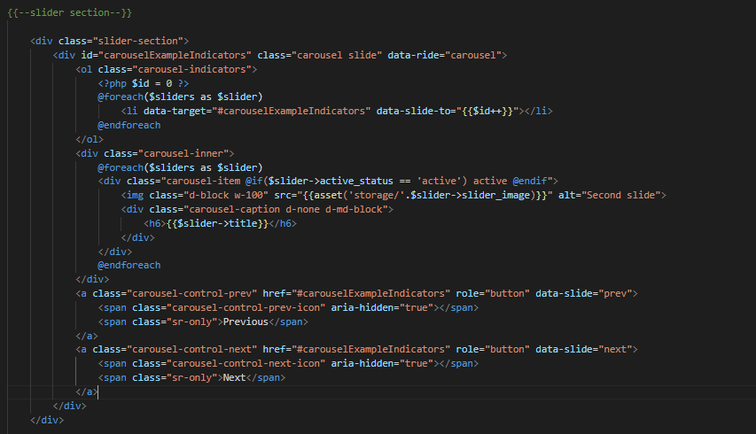

Controller algorithm.

 public function index()

    {

        $sliders = Slider::all();

        $categories = Category::all();

        if (Slider::all()->first()){

            $single_slider = Slider::all()->first();

            $single_slider->active_status = "active";

            $single_slider->save();

        }else{

            $inputs = [];

            $inputs['title'] = "Test title";

            $inputs['slider_image'] = 'https://wallpaperaccess.com/full/2637581.jpg';

            $inputs['active_status'] = "active";

            Slider::create($inputs);

        }

        if (auth()->user()){

            $cart = auth()->user()->cart()->count();

        }else{

            $cart = 0;

        }

        $products = Product::paginate(20);

        return view('pages.sitePage.main-page',compact('products','cart','single_slider','sliders','categories'));

    }